Case Study 06: Tiered Electricity Billing System

1. Problem Statement

Develop a Python program to calculate the monthly electricity charges for a domestic consumer based on a graduated slab tariff system. The program prompts the user to enter the total units of electricity consumed, verifies that the input reading is non-negative, computes tiered energy charges across consumption slabs, adds a fixed meter service charge of Rs. 50, levies an additional 5% surcharge if total consumption exceeds 300 units, and outputs an itemized bill breakdown.

2. Objectives

- To validate consumer consumption data against negative numerical inputs.

- To implement multi-tier progressive pricing algorithms using conditional ladder logic (if-elif-else).

- To account for fixed service fees and conditionally apply percentage-based surcharges on high-volume consumption.

- To compute, format, and display the breakdown between base energy charges and the final payable bill.

3. Assumptions

- Units consumed are recorded as integer values.

- The progressive tariff structure applies as follows:

  - First 100 units: Rs. 2.00 per unit.

  - Next 100 units (101 to 200): Rs. 3.00 per unit.

  - Beyond 200 units: Rs. 5.00 per unit.

- A flat fixed surcharge of Rs. 50 is added to every valid bill.

- If consumption strictly exceeds 300 units, a 5% surcharge is levied on the entire aggregate sum (energy charges + fixed fee).

- All final currency amounts are rounded to two decimal places.

4. Algorithm

- Step 1: Start the program.

- Step 2: Prompt the user to input electricity consumption: units = int(input(...)).

- Step 3: If units < 0, print "Invalid units" and proceed to Step 9.

- Step 4: Calculate energy charges based on consumption slabs:

  - If units <= 100: energy = units * 2.

  - Else if units <= 200: energy = 100 * 2 + (units - 100) * 3.

  - Else: energy = 100 * 2 + 100 * 3 + (units - 200) * 5.

- Step 5: Add fixed meter service charge: bill = energy + 50.

- Step 6: Check if units > 300. If true, apply surcharge: bill = bill * 1.05.

- Step 7: Display the computed energy charge: "Energy charge: Rs. <round(energy, 2)>".

- Step 8: Display the total payable amount: "Total bill: Rs. <round(bill, 2)>".

- Step 9: Stop the program.

5. Flowchart Logic / Diagram

Plaintext
[Start]
│
▼
[Input units (int)]
│
▼
<units < 0?>
│ │
(Yes)│ │(No)
▼ ▼
[Print "Invalid"] <units <= 100?> ────(Yes)───> [energy = units * 2]
│ │ │
│ (No) │
│ ▼ │
│ <units <= 200?> ─────────(Yes)───> [energy = 200 +
│ │ (units-100)*3]
│ (No) │
│ ▼ │
│ [energy = 500 + │
│ (units-200)*5] │
│ │ │
│ └─────────────────┬──────────────────┘
│ │
│ ▼
│ [bill = energy + 50]
│ │
│ ▼
│ <units > 300?>
│ │ │
│ (Yes)│ │(No)
│ ▼ │
│ [bill = bill * 1.05] │
│ │ │
│ └──────┬─────┘
│ │
│ ▼
│ [Print energy and bill]
│ │
└───────────────────┬───────┘
▼
[End]

6. Pseudocode

Plaintext
BEGIN
PRINT "Enter units consumed: "
READ units

IF units < 0 THEN
PRINT "Invalid units"
ELSE
IF units <= 100 THEN
energy = units * 2
ELSE IF units <= 200 THEN
energy = (100 * 2) + ((units - 100) * 3)
ELSE
energy = (100 * 2) + (100 * 3) + ((units - 200) * 5)
END IF

bill = energy + 50

IF units > 300 THEN
bill = bill * 1.05
END IF

PRINT "Energy charge: Rs.", ROUND(energy, 2)
PRINT "Total bill: Rs.", ROUND(bill, 2)
END IF
END

7. Python Source Code

Python
# Tiered Electricity Billing System

# Read electricity consumption
units = int(input("Enter units consumed: "))

# Validate inputs
if units < 0:
print("Invalid units")
else:
# Compute slab-based tiered energy charge
if units <= 100:
energy = units * 2
elif units <= 200:
energy = 100 * 2 + (units - 100) * 3
else:
energy = 100 * 2 + 100 * 3 + (units - 200) * 5

# Add flat meter service charge
bill = energy + 50

# Levy 5% surcharge for high consumption (>300 units)
if units > 300:
bill = bill * 1.05

# Display billing breakdown
print("Energy charge: Rs.", round(energy, 2))
print("Total bill: Rs.", round(bill, 2))

8. Test Cases

Test Case ID | Input Given | Expected Output | Actual Output | Status
TC_01 (Slab 1) | Units = 80 | Energy charge: Rs. 160  Total bill: Rs. 210 | Energy charge: Rs. 160  Total bill: Rs. 210 | Pass
TC_02 (Slab 2) | Units = 150 | Energy charge: Rs. 350  Total bill: Rs. 400 | Energy charge: Rs. 350  Total bill: Rs. 400 | Pass
TC_03 (Slab 3 - No Surcharge) | Units = 250 | Energy charge: Rs. 750  Total bill: Rs. 800 | Energy charge: Rs. 750  Total bill: Rs. 800 | Pass
TC_04 (Slab 3 - With Surcharge) | Units = 350 | Energy charge: Rs. 1250  Total bill: Rs. 1365.0 | Energy charge: Rs. 1250  Total bill: Rs. 1365.0 | Pass
TC_05 (Invalid Input) | Units = -20 | Invalid units | Invalid units | Pass

9. Output Screenshots

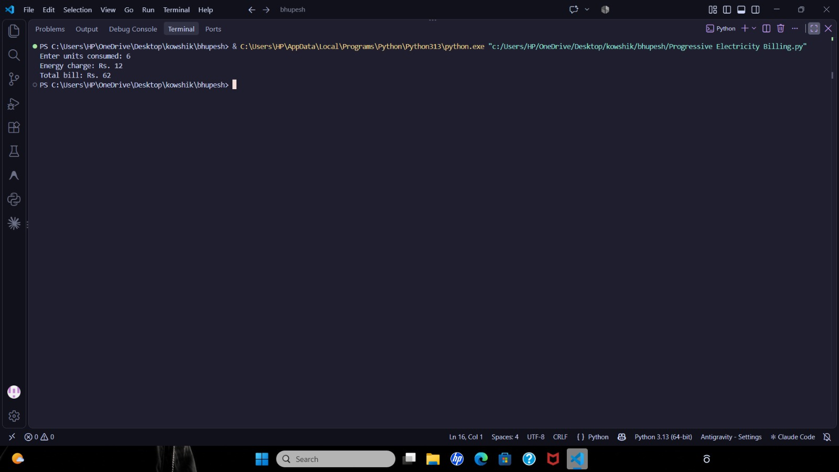

10. Conclusion

The Tiered Electricity Billing System was successfully implemented and verified. The script highlights the application of conditional statements, incremental arithmetic calculation for tiered structures, fixed surcharge adjustments, and high-load conditional penalties.

